TAIWAN – TOUCH YOUR HEART

Taiwan is still one of the better-kept secrets in the world of travel. From secluded islands to industrial estates, karaoke bars to Peking opera, Taiwan has it all. With some of the world's finest Chinese art, antiquities and cultural performances, Taiwan is also where much of Asia's money is made.

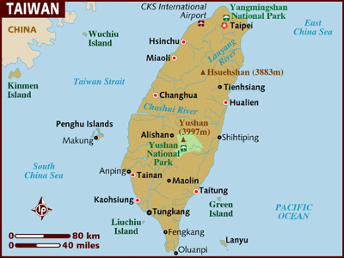

LOCATION :
Taiwan is located in the western Pacific Ocean 160 km off the southeastern coast of the Chinese mainland. Positioned midway between Korea and Japan to the north and Hong Kong and the Philippines to the South, this Island is a convenient gateway to Asia.

Taiwanese territory also incorporates many small offshore island chains.

VISA The visa is to be obtained prior to arrival in the country

HOW TO GET THERE :
International Airport : The International airports in Taipei and Kaohsiung are served by a wide number of International and Asian airlines, with excellent global connections.

GETTING AROUND :
Air : Taiwan has two international airports.
Chiang Kai-Shek Taipei is 40km (25miles) south of the capital - the journey into the city takes up to an hour by taxi or bus. There are also regular buses to the main railway station.
Kaohsiung International Airport is 9km (6miles) from Kaohsiung in the South of the island; travel into the centre takes around 30mins by bus or taxi.
Taiwan has air links with most international hubs apart from mainland China. Domestic air travel is not uncommon, despite the relatively small size of Taiwan. Sung Shan Domestic Airport connects Taipei with cities around the island. The main domestic carriers are Far Eastern Air Transport, Mandarin Airlines, Trans Asia Airways and Uni Air.

Train :
Rail is one of the most convenient ways to explore Taiwan. Trains are clean, air-conditioned and reliable. The main train station in Taipei, in a rare gesture at making life easier for foreigners, has an English language information booth at the eastern counter as well as English language boards.
There are four classes of travel, ranging from the expensive but fast top category to the slow bottom class, which is cheaper than the bus but only recommended if you have plenty of time on your hands. Contact the Taiwan Railway Administration for schedules. Tickets are available at stations and most major Taipei hotels. Kids under three travel free while children aged 13 and under travel for half price.
Taipei's Mass Transit Railway and monorail serves the capital and its suburbs and is a surprisingly clean and efficient way to travel around the city sprawl.

Bus :
Taiwan has a widespread and reliable network of bus services. Government run buses have two separate classes- Kuokuang (luxury) and Chunghsing (economy).
There are numerous private bus and coach services with a wide range of services and comfort levels. Tickets can be booked in advance from travel agencies.

The following table provides approximate driving distances between selected cities. Kilometres in the lower left of the table, miles in the upper right.
City | Tai | Taic | Tain | Olua | Tait | Hua | Hsin | Miao | Cha | Kao | Fen
Taipei | • | 80 | 164 | 260 | 200 | 104 | 46 | 64 | 103 | 212 | 256
Taichung | 130 | • | 80 | 161 | 102 | 54 | 50 | 27 | 10 | 13 | 100
Tainan | 264 | 130 | • | 80 | 62 | 108 | 132 | 109 | 72 | 22 | 60
Oluanpi | 420 | 260 | 130 | • | 55 | 148 | 195 | 178 | 144 | 58 | 18
Taitung | 322 | 165 | 101 | 90 | • | 90 | 136 | 123 | 98 | 49 | 46
Hualien | 168 | 88 | 174 | 239 | 146 | • | 66 | 59 | 55 | 121 | 136
Hsinchu | 75 | 81 | 213 | 315 | 220 | 107 | • | 20 | 58 | 152 | 179
Miaolo | 104 | 44 | 176 | 287 | 198 | 96 | 33 | • | 37 | 134 | 161
Changhua | 167 | 17 | 117 | 233 | 158 | 90 | 94 | 60 | • | 98 | 128
Kaohsiung | 342 | 22 | 36 | 94 | 80 | 195 | 246 | 216 | 159 | • | 98
Fenhang | 412 | 162 | 97 | 30 | 75 | 220 | 289 | 260 | 207 | 60 | •

CURRENCY :
Taiwan’s official currency is the New Taiwan Dollar (NT$). Coins come in denominations of NT$1, 5,10 and 50 while notes are issued in values of NT$50,100, 500 and 1000.

BUISNESS :
Banks: Monday - Friday 0900 to 1530
Shops in Taiwan are generally open from 10h00-22h00 Monday to Saturday, although many also open on Sundays

CLIMATE :
Taiwan’s subtropical climate, with generally warm temperatures and Northern Hemisphere Summers (June-September) and Winters (November-March) Summers can be hot and wet, although rainfall is often limited to afternoon and evening storms. Winter temperatures are mild and the only snowfall is on Mountain peaks.
The best time to visit is October/November, when the temperature is warm, but not boiling, and the typhoon season is usually over.

TIME :
Taiwan is 2 hrs. ahead of India (IST)

ELECTRICITY :
Electricity is 110 Volts, 60 cycles AC. Visitors should carry a multi-plug adaptor for local sockets

DIALLING CODE :
International dialling code: | 886
Area codes: | Taipei, Keelung: 2, Kaohsiung: 7, Taichung: 4, Tainan: 6

TIPS :
It is not customary to tip in Taiwan.

LANGUAGE :
Taiwan’s official language is Mandarin Chinese. Other languages spoken include English and some aboriginal languages and dialects

INFORMATIVE WEBSITE :
www.go2taiwan.net

CITIES :
TAIPEI :
It's home to nearly three million, it's the seat of the national government, it's one of the island's main transport hubs, and it's the northern terminus of the Taiwan High Speed Railway (THSR). Taipei City, the capital of Taiwan, is close to the island's main international airport, and the usual place for foreign visitors (both business and leisure travelers) to start a trip to Taiwan.

Accomodation Options in Taipei :
Hotels are spread throughout the city, with a concentration around the main train station. Don't take a room of any type without air-conditioning in the summer; it just isn't worth it.
The entire length of Chungshan Road and its surrounding streets contains the best of the city hotels. All are modern and offer easy access to the city attractions, and main entertainment areas. Just off Chungshan, the Caesar Park is typical of the hotels in this area.
Clusters of hotels are also found to the east of the city towards the domestic airport and around the convention centre and the Sun Yat-Sen Memorial Hall. The KDM makes a great base if you want a good value hotel right in the heart of the city, with comfortable accommodation and easy access to the main sights and entertainment in the city.
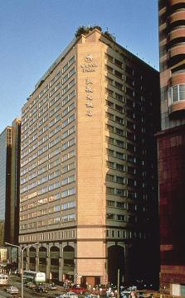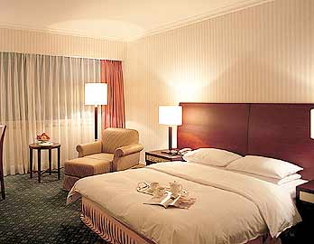
MUST – SEES :
National Palace Museum :
The National Palace Museum boasts the world's largest and most important collection of Chinese cultural artefacts, with far more ink paintings, calligraphy scrolls, woodcarvings and jade curios than can be displayed at any one time.
The displays are changed every few months to show all of the collection, but even so it takes 12 years for artefacts to cycle through. As well as the permanent displays there is a constant programme of special exhibitions and events that showcase various parts of the collection, or visiting exhibitions from other international institutions.
221 Chih-shan Rd Section 2. Open: daily 09h00-17h00. English-language tours (no extra charge) at 10h00 & 15h00. Admission: NTD100, adults; NTD50, children. Bus 255 or 304 from Shihlin MRT station.

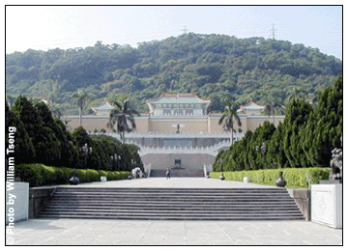

Lungshan Temple :
More than 250 years old and one of Taiwan's most famous places of worship, this picturesque and perpetually bustling temple - situated in the historic Wanhua neighbourhood - draws thousands of Buddhists and Taoists each day.
Ahead of exams students flock here to petition the gods for good luck. As with all Taiwanese shrines, admission is free, but be sure to respect the worshippers here - this is not merely for the benefit of tourists but a shrine in every day use.
211 Kuangchou St. MRT: Lungshan Temple. Open: daily 06h00-22h00.
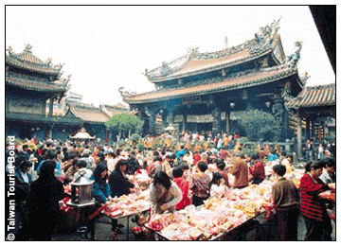

Chiang Kai Shek Memorial :
The Chiang Kai-Shek Memorial is dedicated to the Nationalist leader, who died in 1975. The hall itself is an imposing white-and-blue edifice while the surrounding gardens feature reflexology paths and ponds filled with carp.
One of Taipei's most beautiful spaces, The plaza itself is home to both the Taiwanese National Theatre and the National Concert Hall.
21 Jhongshan South Rd. MRT: Chiang Kai-Shek Memorial Hall. Museum

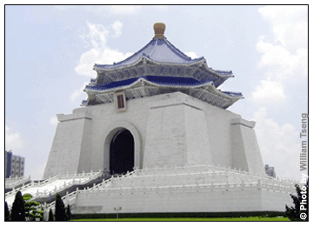

Taipei 101 Observatory :
The latest holder of the world's tallest building title, the recently-opened Taipei 101 Tower's spire soars up to a dizzying 508 metres, eclipsing the former record-holders, the Petronas Towers in Kuala Lumpur and the Sears Tower by a good 50 metres. Situated in the up-and-coming Xin-Yi business district, the pagoda-style steel and glass building contains offices as well as a large shopping, restaurant and entertainment complex and, needless to say, offers amazing views over Taipei.
A lot of the fun is actually getting to the observatory: visitors are swept up to the indoor viewing platform on the 89th floor in the world's fastest elevator - a swift 39-second ride at a speed of 1,010 metres a minute, or just over 60km an hour. From there they can climb a further two floors to the outdoor viewing platform which offers unparalleled vistas over the city and its surroundings (though it has to be said pollution often clouds the views somewhat). The tower is full of superlatives: at the top, you can also see the enormous steel tuned mass wind damper, installed to stabilise the building in strong winds or earthquakes, which is, naturally, the largest of its kind in the world.
8 Sung-Chih Rd, Xin-Yi District (Lift to observatory on the 5th floor). Open: daily 10h00-22h00.

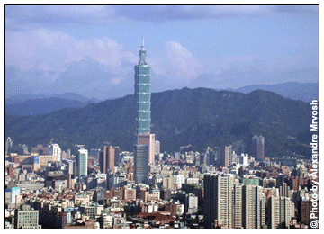

EXCURSIONS :
Wulai Aboriginal Village :
One of the most interesting excursions from Taipei, the Wulai Aboriginal Village is the best place to see the indigenous people of the region. The tribes here were once headhunters, but thankfully have stopped the practice, authenticity can be taken too far.
In fact the village itself isn't wholly authentic - you can see the trappings of the 20th century, and it is always packed with tourists - but the people who inhabit it have stayed true to their cultural heritage. The fantastic waterfalls for which the town is famed are worth seeing, and you can catch traditional performances of dance and music that tell the story of the tribe's history and beliefs.

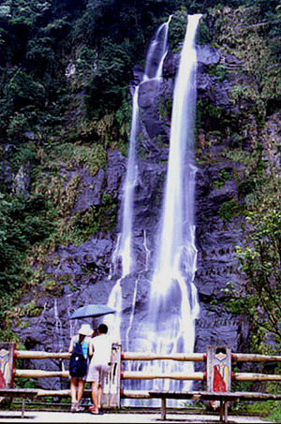

Taroko Gorge :
On the east coast of Taiwan near to the city of Hualien is the small town of Tienhsiang. Although the town is pleasant enough in its own way, visitors come here for Taiwan's most spectacular natural sight - Taroko Gorge.
At over 19km in length it is a spectacular accident of geography. The walls of the steep sided gorge contain quantities of marble, which reflects the white water that constantly forces its way through the narrow defile in a spectacular torrent. At the head of the gorge is the Eternal Spring Shrine, a memorial to the workers who died building the Taroko Gorge highway in 1960.
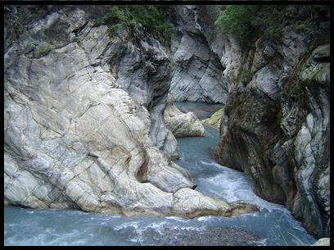

Sun Moon Lake :
Considered one of Taiwan's most scenic regions, Sun Moon Lake is a few hours drive from the capital, in the middle of the island. The vast lake is the largest expanse of inland water in Taiwan, with a 35km circumference.
What really makes Sun Moon a place of beauty, though, is the surrounding region. Steep mountains rise up sharply from the water's edge encircling the lake. Verdant greenery extends down to the shore, and the scene is often compared with the rural images of Chinese scroll paintings, almost a fantasy of a natural idyll.
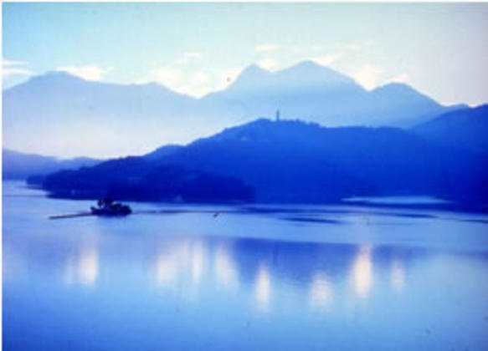

FOOD :

INDIAN RESTAURANTS :

ALI BABA KITCHEN
No 2-B1, Nanking, West rd, Taipei
Tel : (02) 2567 7163

CAFÉ INDIA
30, KoQiang Rd. (Near TianMu Swimming Pool)
Tel : (02) 2837-7365

TANDOOR INDIAN RESTAURANT
10, Lane 73,
HeJiang St.
Tel : (02) 2509-9853 / 2505-4870

SHOPPING :
Shopping in Taiwan can be a lot of fun.
The region's largest nightmarket is Shihlin in Taipei, an Aladdin's cave of weird and wonderful food, clothing and souvenirs. Tainan is a good place to pick up traditional handicrafts or Buddhist souvenirs.
Good buys throughout Taiwan include lacquerware, porcelain and ceramics, many of which can be bought at a fraction of the price elsewhere. Jewellery and trinkets made from veinstone and jade are also very common, and many come in unique designs, though you need to look out for fakes. Taiwan produces some good quality handmade shoes and slippers too, and textiles are often relatively cheap.
Tea and incense are also excellent buys but the massive price ranges may be confusing for a foreigner unfamiliar with the different qualities. Incense, for example, can range in price between NTD50 to NTD6,000 per catty (a unit of weight dating back to colonial times equivalent to around 600g). Tea is an obvious souvenir, and entire tea sets, though perhaps not all that useful when you get back home, can make beautiful ornaments.

